Module Name: Age Validation Selenium Web Form
Test Case ID:A001
Environment:OS:Windows 11, Browser:Chrome ,Website: https://www.selenium.dev

- Scenario ID: 1a
- Scenario: Age below lower boundary
Test step:
- Open Web Form
- locate Age field
- enter age
- Click enter.

Screenshot
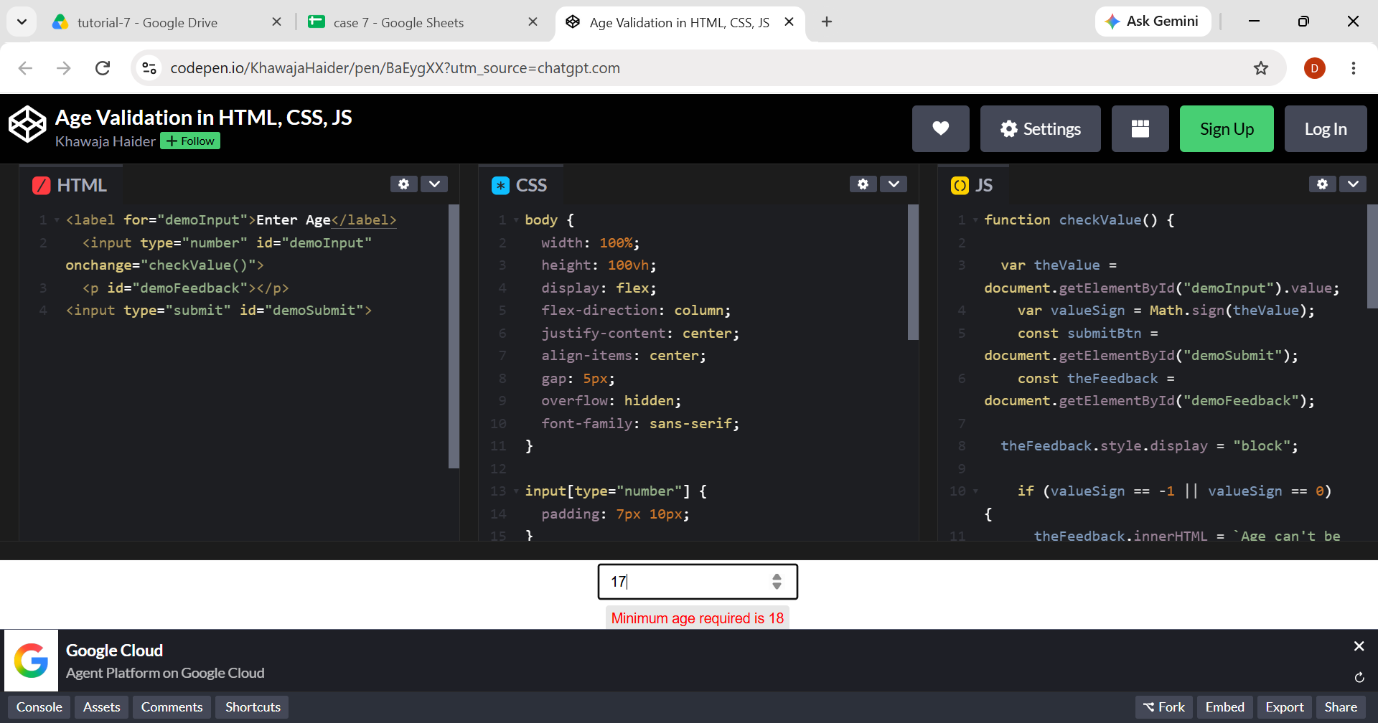

- Scenario ID: 1b
- Scenario: Age at lower boundary
Test step:
- Open Web Form
- locate Age field
- enter age
- Click enter.

Screenshot
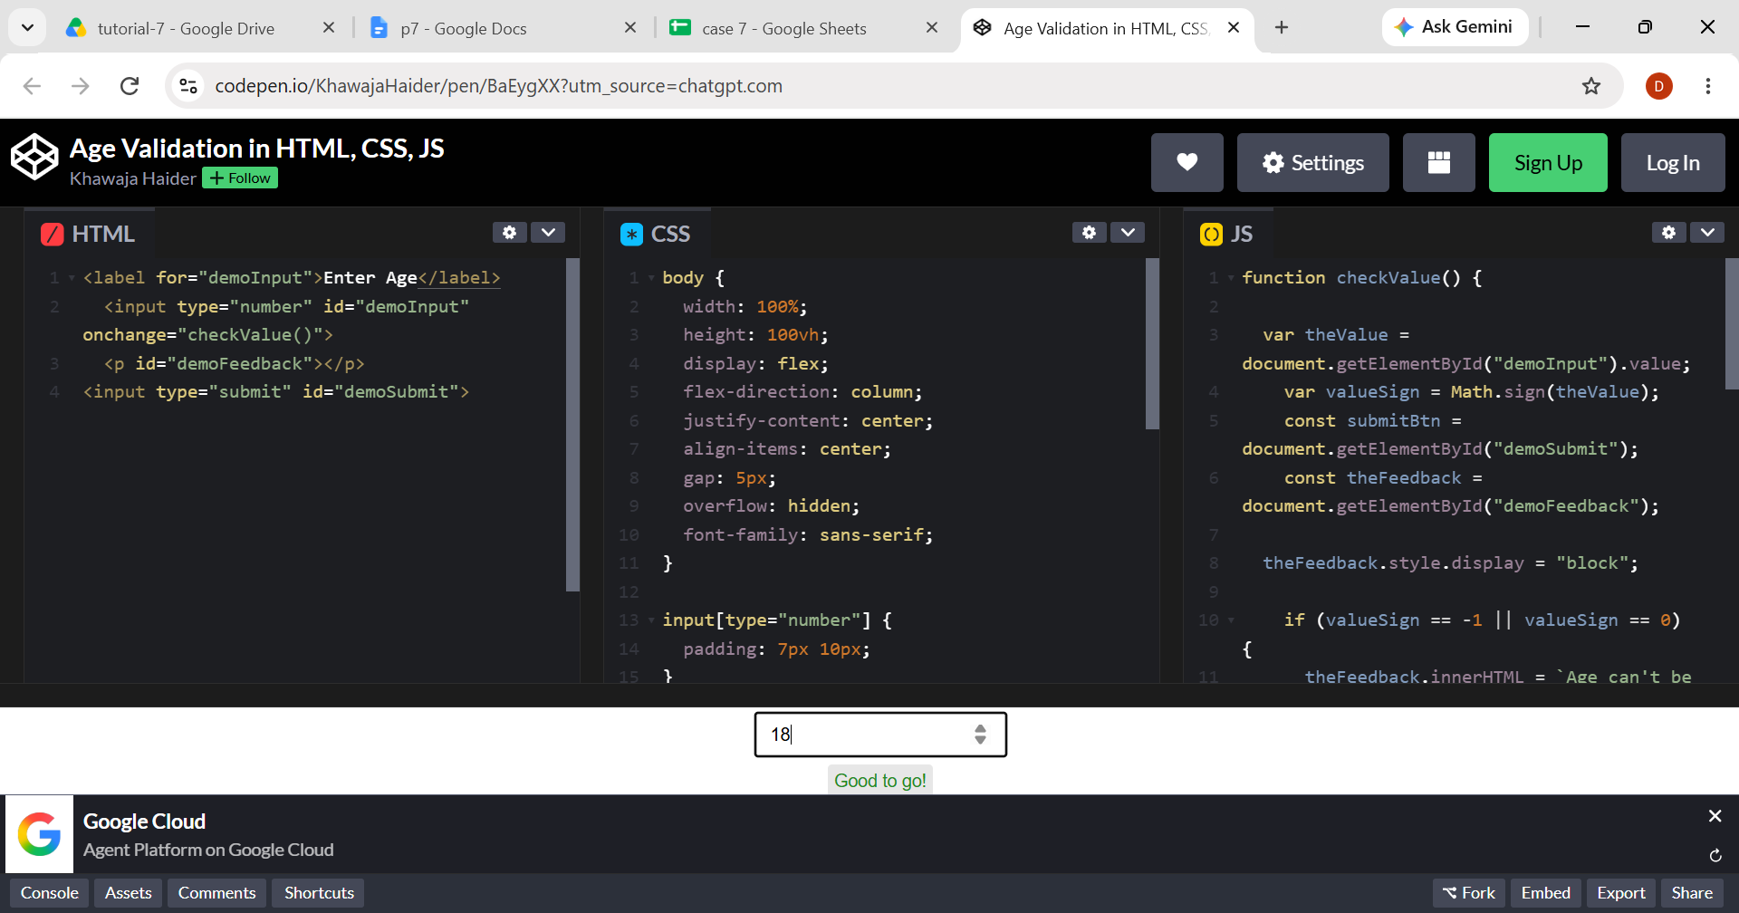

- Scenario ID: 1c
- Scenario: Age just above lower boundary
Test step:
- Open Web Form
- locate Age field
- enter age
- Click enter.

Screenshot
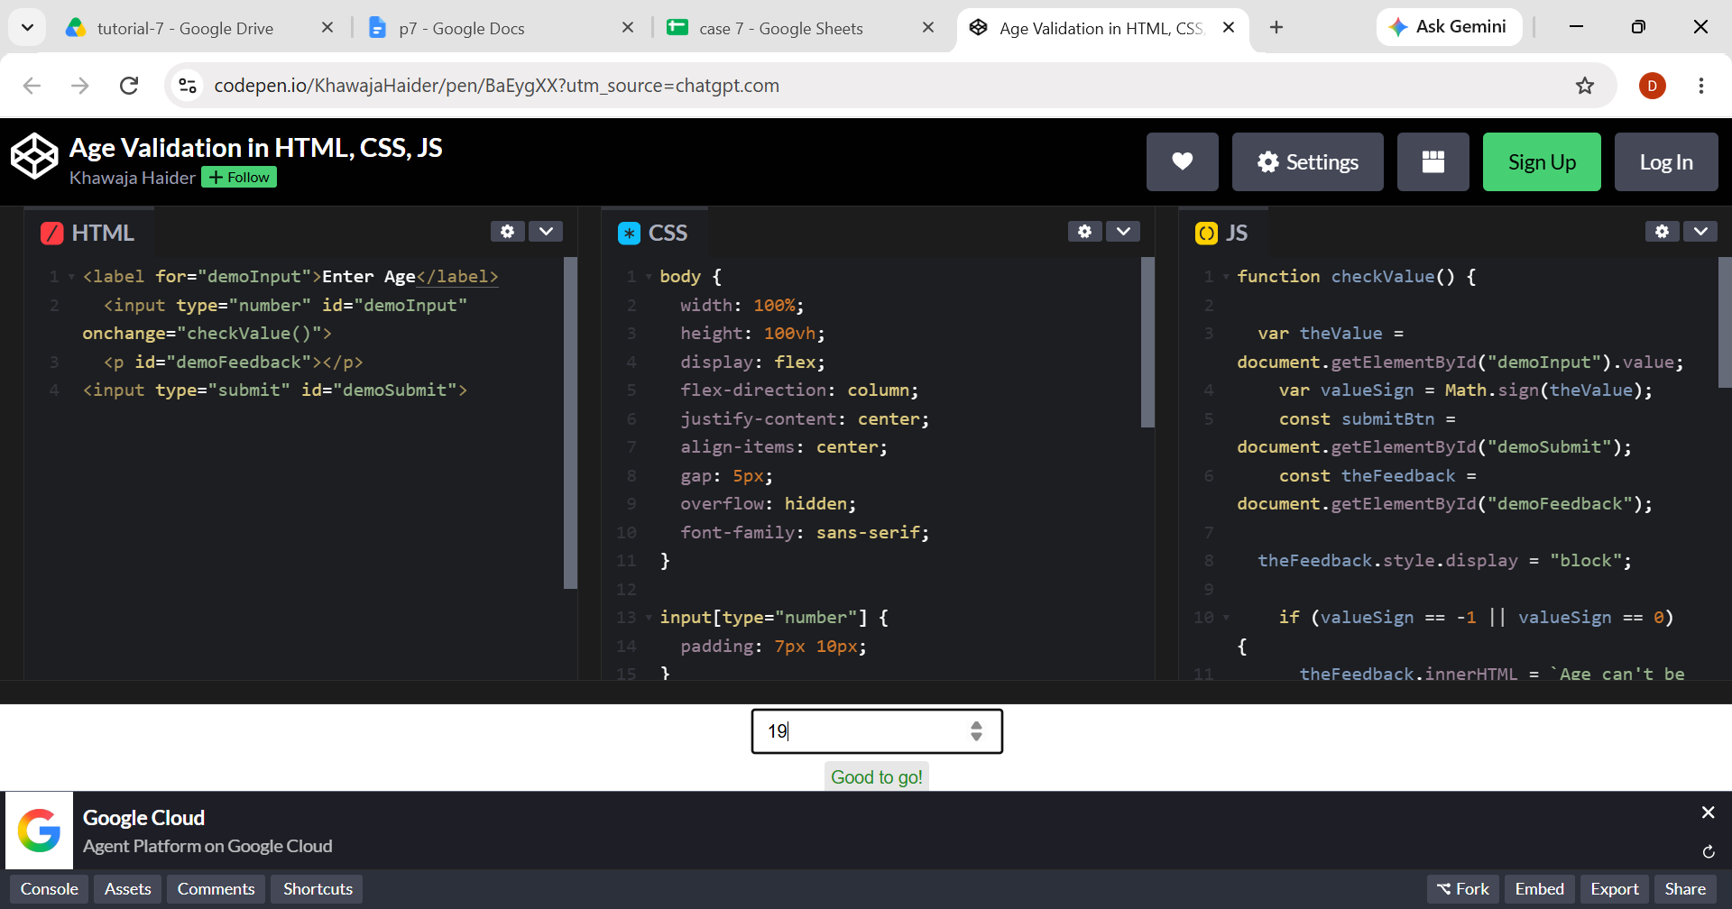

- Scenario ID: 1d
- Scenario: Age just below upper boundary
Test step:
- Open Web Form
- locate Age field
- enter age
- Click enter.

Screenshot
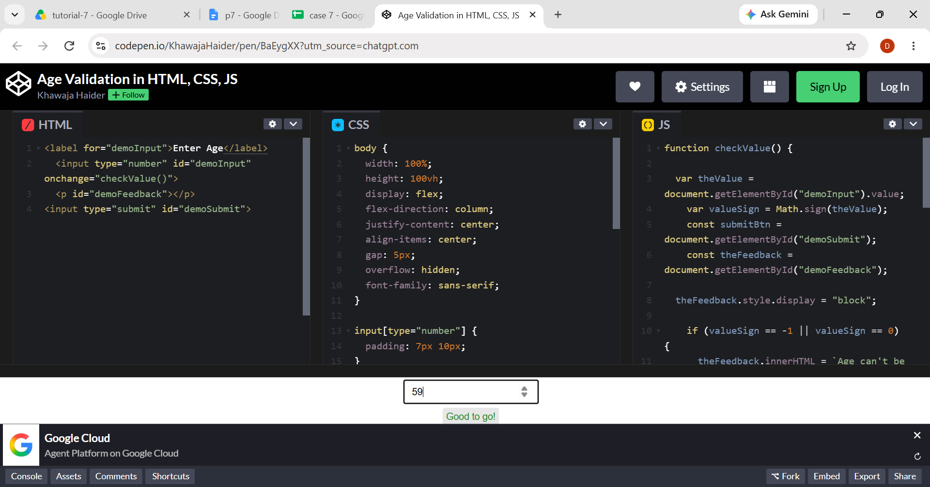

- Scenario ID: 1e
- Scenario:Age at upper boundary
Test step:
- Open Web Form
- locate Age field
- enter age
- Click enter.

Screenshot

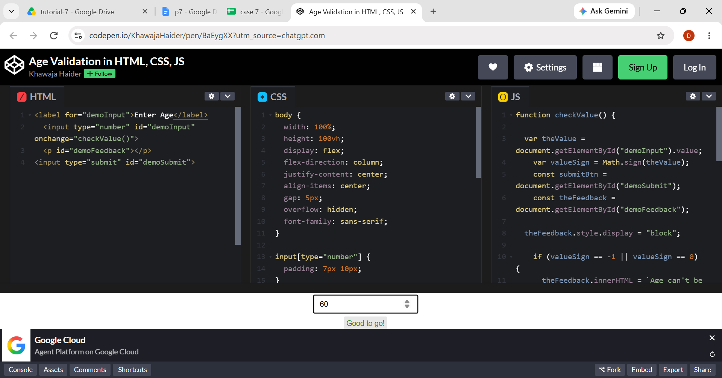

- Scenario ID: 1f
- Scenario:Age above upper boundary
Test step:
- Open Web Form
- locate Age field
- enter age
- Click enter.
